**Year 12 Examination, 2016**

**Question/Answer Booklet**

**MATHEMATICS SPECIALIST**

**Section Two: Calculator-assumed**

Student Name/Number: ______________________________________________

Teacher Name: ______________________________________________

**Time allowed for this section**

Reading time before commencing work: ten minutes

Working time for this section: one hundred minutes

**Materials required/recommended for this section**

**To be provided by the supervisor:** This Question/Answer Booklet

Formula Sheet (retained from Section One)

**To be provided by the candidate:**

Standard items: pens (blue/black preferred), pencils (including coloured), sharpener, correction fluid/tape, eraser, ruler, highlighters

Special items: drawing instruments, templates, notes on two unfolded sheets of A4 paper, and up to three calculators approved for use in the WACE examinations

**Important note to candidates**

No other items may be taken into the examination room. It is **your** responsibility to ensure that you do not have any unauthorised notes or other items of a non-personal nature in the examination room. If you have any unauthorised material with you, hand it to the supervisor **before** reading any further.

**Section Two: Calculator-assumed 65% (101 Marks)**

This section has **13** questions. Answer **all** questions. Write your answers in the spaces provided.

Spare pages are included at the end of this booklet. They can be used for planning your responses and/or as additional space if required to continue an answer.

* Planning: If you use the spare pages for planning, indicate this clearly at the top of the page.
* Continuing an answer: If you need to use the space to continue an answer, indicate in the original answer space where the answer is continued, i.e. give the page number. Fill in the number of the question that you are continuing to answer at the top of the page.

Suggested working time: 100 minutes.

**Question 8 (4 marks)**

Consider the graph of  as shown below.

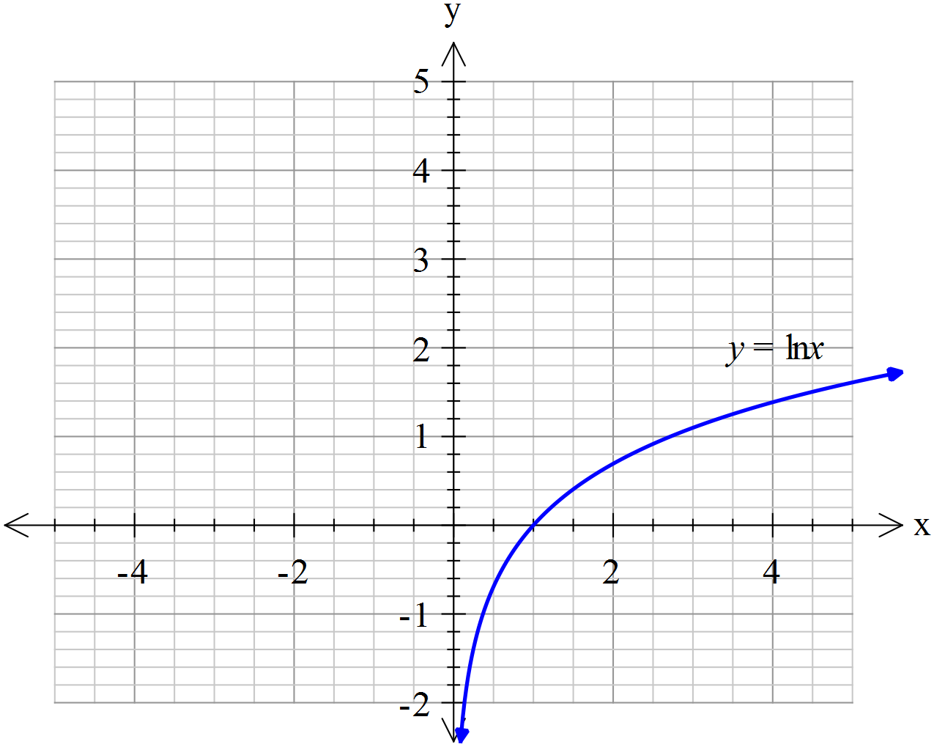

1. Sketch the function  on the axes above. (2 marks)
2. Determine the gradient function for . (2 marks)

**Question 9 (7 marks)**

A certain type of battery is being considered by a car manufacturer for a new electric car. The manufacturer collected a sample of 35 such batteries and found that the mean life span was 866 days with a sample standard deviation of 97 days.

1. Assuming a normal distribution for the sample means determine a 95% confidence interval for the population mean life span of the battery. (3 marks)
2. If the manufacturer collected a new sample of 35 such batteries, determine the probability that the mean life span will be greater than 880 days. (2 marks)
3. The manufacturers are looking for a battery to last 900 days. Would you advise that they use this type of battery? Justify your answer. (2 marks)

**Question 10 (9 marks)**

Consider the area between the curves  and the lines and  as shown below.

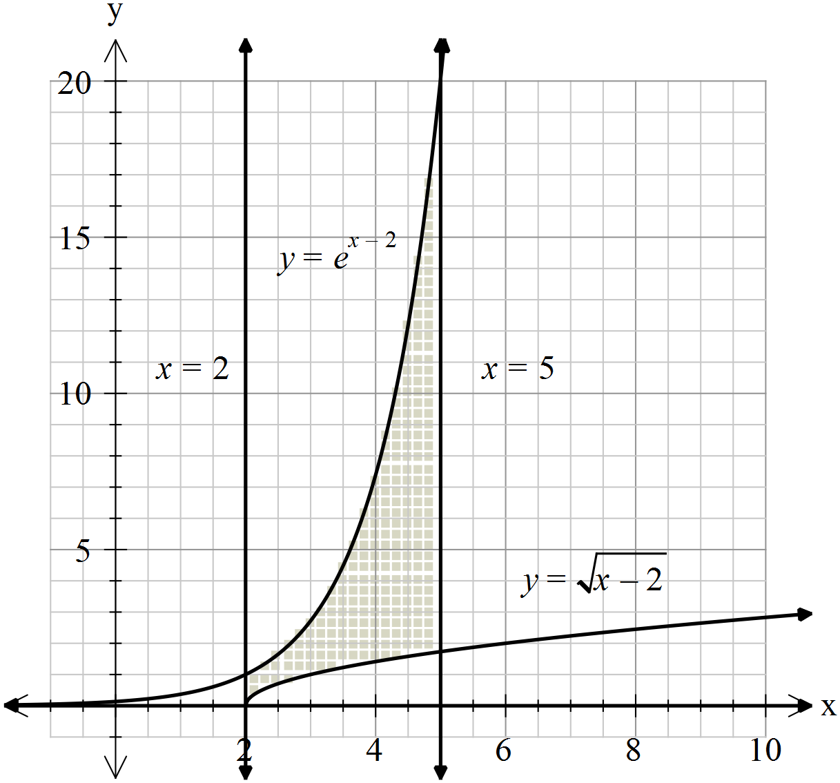

1. Calculate the area shown above. (3 marks)

The area shown above is rotated about the *x*-axis forming a three-dimensional object with a cavity (space) that has capacity.

1. Determine the capacity of this object. (3 marks)
2. Determine the volume of the walls of this object. (3 marks)

**Question 11 (7 marks)**

A complex number , is defined by  and .

1. On the polar grid below, graph the sequence  for integers, . (4 marks)

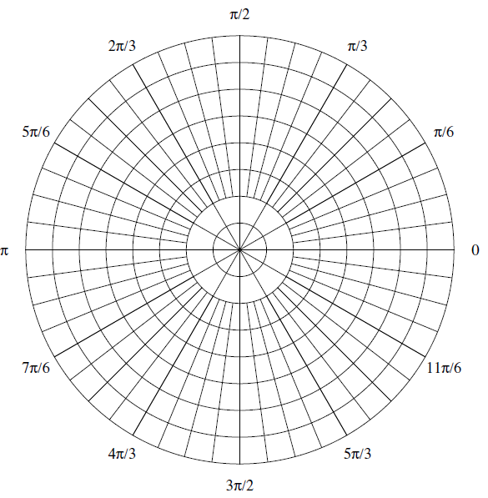

**Question 11(continued)**

1. Hence or otherwise find the value(s) of *,* where  is an integer  ,

such that  and . (3 marks)

**Question 12 (7 marks)**

The graph of the equation $x^{2}-4xy+4y^{2}-5x+4=0$ is a parabola.

1. Find the equation of the tangent to the parabola at the point $P(4,0)$. (4 marks)
2. Find the coordinates of the point $Q$ on the parabola where the tangent is parallel to the $y-$ axis. (3 marks)

**Question 13 (10 marks)**

The position vector $r(t)$ of a moving particle $P$ at time $t$ is given by

$r\left(t\right)=\left(2t+5\right)i+\left(2t-7\right)j+(5-t)k$.

1. Describe the path traced out by $P$. (1 mark)
2. Find the point where the path of $P$ meets the plane whose equation is

$3x+4y-6z=37$.

(2 marks)

1. Find the minimum distance between the path of $P$ and the origin $O(0,0,0)$. (3 marks)
2. Show that $r\left(t\right),$ the position vector of $P$ at time $t$, and $v(t)$**,** its velocity, are mutually orthogonal when $P$ is closest to the origin. (2 marks)

The angular momentum of $P$ at time $t$ is the vector $H(t)$ defined by

$$H(t)=m\left(r(t)×v(t)\right)$$

where $m$ is the mass of $P.$

1. Show that the angular momentum of $P$ is constant. (2 marks)

**Question 14 (6 marks)**

1. Show that the complex number  is a root of

. (3 marks)

1. Using the result from (a) determine all the roots of , justifying your solution and describing the nature of each of the roots. (3 marks)

**Question 15 (8 marks)**

A quality control unit at a large warehouse will be checking the mean weight of the cans of tomatoes that are stored at the warehouse. The population standard deviation of the weight is 55 grams.

1. Determine the sample size if we want to be 90% confident that the mean of the sample is within 10 grams of the population mean. (3 marks)
2. Determine the sample size if we want to be 65% confident that the mean of the sample is within 10 grams of the population mean. (3 marks)
3. A sample is to be chosen such that we are 99% confident that the sample mean is within 10 grams of the population mean. By what factor should the sample size be changed such that the confidence interval is one third in length but to the same degree of confidence? (2 marks)

**Question 16 (13 marks)**

Let the function  be defined as follows .

1. Explain why does not have an inverse over its natural domain. (1 mark)
2. If we restrict the domain of  to , determine . (3 marks)
3. Determine the domain and range of . (2 marks)
4. Sketch  and  from part (b) on the axes below. (4 marks)

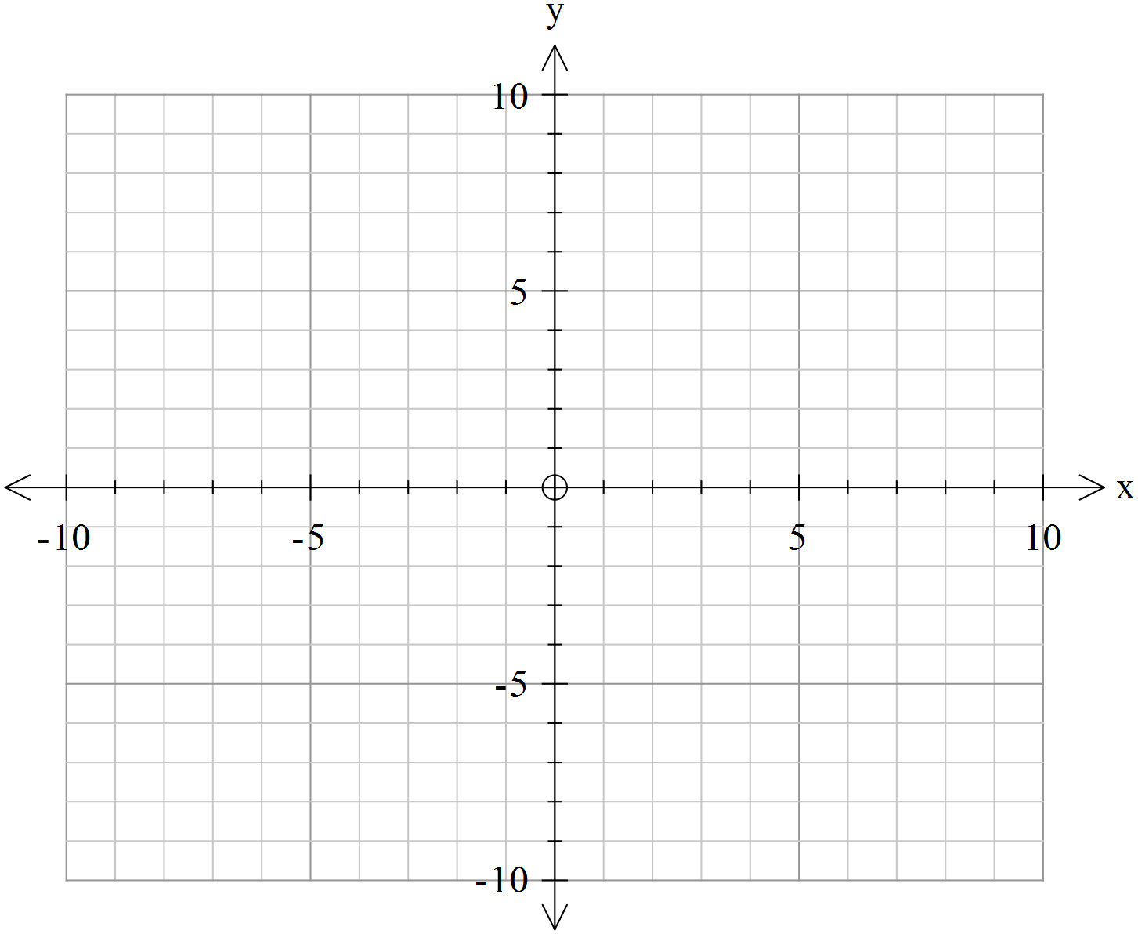

1. Solve to one decimal place showing these points on the graph in part (d). Comment on these points. (3 marks)

**Question 17 (5 marks)**

In $M$ is the midpoint of the side $AB$ and $N$ is the midpoint of the side $BC.$

C

N

A M B

1. Show that $\vec{MN}=\frac{1}{2}\vec{AC}$. (2 marks)
2. Deduce that the midpoints of the sides of any quadrilateral are the vertices of a parallelogram. (3 marks)

M B

A

N

Q

D P C

**Question 18 (7 marks)**

At a given time, *t* (=0)hours, a petri dish contains 0.2 grams of a particular bacteria. Sometime, *t* hours later, the bacteria had increased to an amount *N* (measured in grams). The rate of increase of the bacteria can be modelled by the logistical equation:



The general solution to the logistical equation is given by .

1. Determine the value of the constant *C.* (1 mark)
2. Determine the limiting value of *N.* (1 mark)
3. Given , determine the values of the constants *A* and *B.*

(2 marks)

1. Using the rate of change equation and solving by separation of variables and partial fractions, show how to derive the general solution for *N.* (3 marks)

**Question 19 (12 marks)**

The displacement $x$ m and the velocity $v$ m/sec of a particle moving along a straight line are related according to the equation

$9x^{2}+16v^{2}=25$.

1. Explain why the particle never moves faster than $1.25$ m/sec. (2 marks)
2. Show that $16a=-9x,$ where $a {\text{cm/sec}}^{2}$ is the acceleration. (2 marks)
3. Determine the amplitude and period of this simple harmonic motion. (3 marks)
4. Determine the first time at which the displacement of the particle is a maximum, given that initially the velocity of the particle is 1 cm/sec and this is increasing. (5 marks)

**Question 20 (10 marks)**

The height $h(t)$ metres of a hot-air balloon $t$ seconds after take-off satisfies

 .

1. How long does it take the balloon to rise 1 kilometre? (5 marks)

The air temperature $T ℃$ at height $h$ metres is given by

 .

1. Estimate the amount by which the temperature outside the balloon decreases in the 5 second period that starts when the balloon is 200 metres high. (5 mark)